*Delete and add an image here.*

### Type the Game Title

**Directions:** Use Avery business cards to create game cards. Download the [**Avery Template for Word software**](http://www.avery.com/us/Main?action=software.AverySoftwareDetail&catalogcode=WEB01&softwarecode=3201) online (<http://www.avery.com/us/software/jcc/> )Players roll the die, take a card, answer the question correctly and move the number of dots on the die. First player to reach the end of the game wins. Continue playing to find out who comes in second, third, and fourth place.

Ideas for game cards:

* Reading vocabulary words
* Science vocabulary words
* Social Studies vocabulary words
* Parts of speech
* Phonic sounds
* Proper/common nouns
* Singular/plural words
* Story comprehension questions
* Math facts
* Telling Time
* Punctuation marks

**Game Tokens:**

Delete and replace with game token

Delete and replace with game token

Delete and replace with game token

Delete and replace with game token

**?**

**?**

**?**

**?**

**The (Your Class) Music Game**

**? ?**

**?**

**Directions**

**Choose a person to draw the cards and**

**read the questions. Roll dice/flick spinner. Move**

**marker that many spaces. Card is drawn on**

**when you land on the question mark. Correct**

**answer will advance you, wrong answer will**

**move you back.**

**Go back 2 spaces**

**Go back 2 spaces**

#### **END**

**Miss one turn**

**Go ahead 2 spaces**

# START

# Take

# the

# Shortcut Pass

**Take an extra turn**

**?**

**Go ahead 2 spaces**

Miss one turn

**Go back 2 spaces**

**?**

**Go ahead 2 spaces**

# Take the

# Shortcut

## Pass

**?**

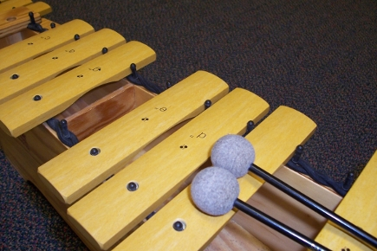

Put Your Pic Here